
International Student Prospectus

Welcome from the Principal

Kia ora, and a very warm welcome to Mauku School.

On behalf of our staff and students, we are truly delighted that your family has joined our incredible learning community.

Choosing Mauku School means choosing an authentic New Zealand primary school experience. We are a vibrant and creative school situated close to Pukekohe. This location offers a peaceful learning environment, providing an unforgettable taste of Kiwi life, while being conveniently located only about 35 minutes from Auckland International Airport, making your travels straightforward.

We are a well-resourced school with a dedication to ensuring your child enjoys the very best learning experiences. Our staff is an exceptional team of passionate teachers and support staff who go above and beyond for our students. They provide high-quality teaching and experiences where children can be confident, eager to collaborate, and engaged in learning. Your child will be welcomed by our friendly children and will join a supportive community with a strong sense of partnership with our parents.

We are confident that Mauku School will provide a truly memorable, enriching, and unforgettable chapter in your child's educational journey. We look forward to getting to know your family and welcoming you into the Mauku whānau (family).

James Christie
Principal

Mission Statement

If we care for ourselves, others and our environment
Then we contribute to our world
And together we conquer our challenges and achieve our dreams

Strategic Goals

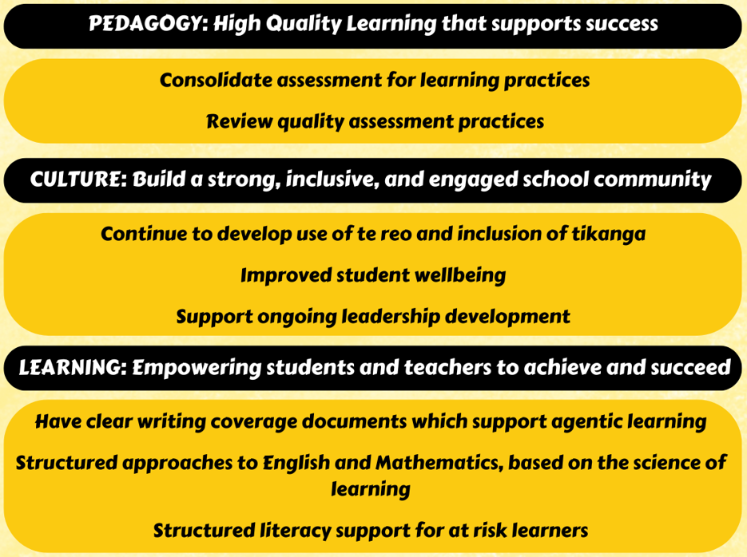

School Overview

 | Mauku School is nestled amidst the picturesque paddocks and pastures of the Franklin District, offering a serene, country-like setting.  We are approximately 35 minutes drive from the Auckland International Airport (AKL), ensuring a straightforward and stress-free arrival for international students and their families.  Locally, we are just 10 minutes drive from Pukekohe, a thriving community hub. Pukekohe provides all necessary amenities, including excellent shopping, a variety of cafes and restaurants, healthcare services, and local entertainment. Our close proximity to Pukekohe High School is especially convenient for families who have older siblings enrolled in their international student programme.  For student transport, Mauku School operates a dedicated school bus service for the local area. Detailed route and schedule information will be provided upon enrolment. Alternatively, families are welcome to drive their children to school.  Education Review Office  Mauku School is regularly reviewed by the Education Review Office (ERO), New Zealand’s external evaluation agency for schools.  The latest ERO report highlights the school’s strong learning environment, commitment to student wellbeing, and focus on high-quality teaching and learning.  You can view the full report here: https://www.ero.govt.nz/institution/1366/mauku-school

Why Choose Mauku School?

- Safe and welcoming rural environment
- Small class sizes and personalised learning
- Strong pastoral care and student support
- Authentic New Zealand school experience
- Close proximity to Auckland International Airport
School Day and Bell Times

Our daily schedule for students across Years 0 to 6 is structured to maximise learning and wellbeing.
7:50 Bus students arrive / Breakfast Club
8:15 Drop-off for non-bus students
8:45 School starts
9:50 – 10:00 Brain Food Break
11:00 – 11:30 Morning Tea Break
1:00 – 1:30 Lunch Break
2:35 Bus students leave
2:45 End of School (Pick-up for all non-bus students)

We hold school assemblies twice a week at 9:00 on Monday and Friday mornings.
School Organisation

Our school is a contributing school for students across Years 0 to 6.
We have 7 classrooms and work in 2 teams (Junior and Senior).
We have 5 Whanau Groups (Karaka, Whero, Kakariki, Kowhai, and Kikorangi).
Facilities

Our facilities include the following:
- A pool
- Sports courts
- Playground areas
- 2 large playing fields
- Bike track
- Vegetable gardens
- Canopies
- An orchard
School Uniform
All students are required to wear the Mauku School uniform.
School polo shirts, jerseys, and hats are available from the school office. Payment can be made through your MyKindo account.
- Polo Shirts: $32
- Jerseys: $38
- Hats: $15
Our school uniform consists of a polo shirt and black shorts (any black shorts are acceptable). We also offer school jerseys, and students require school hats in terms 1 and 4. All uniform items are supplied by the school. Short-term students are required to return these at the completion of their stay, or they can be purchased through the office. Long-term students may keep their uniform.
We provide a sports uniform for sports tournaments, which is loaned to students.
School Rules
At Mauku School, we aim to create a safe, respectful, and positive learning environment. Our core principle is simple: We respect, help, and support each other. Courtesy and respect must be shown to all students and staff at all times.
For safety, students are not to leave the school grounds unless accompanied by an authorised adult. The Staffroom and classrooms during break times (unless it's raining) are out of bounds. For sun safety, hats must be worn outside during Terms 1 and 4.
Only the Mauku School uniform is to be worn. Upon arrival, students must complete a cyber safety agreement. Mobile phones are handed in to the school office upon arrival and collected at the end of the day.
International Student Programme

Our programme at Mauku School is designed to ensure a welcoming, supportive, and academically rich experience for every international student. We focus on seamless integration into school life while providing targeted language assistance.
Mauku School welcomes international students in Years 0–6 for both short-term and long-term study programmes.
Students will be placed in a class with students of the same age to ensure full immersion and social integration. We offer a balanced and comprehensive New Zealand curriculum, covering Mathematics, Reading, Writing, The Arts, Social Sciences, Health and Physical Education, and Science. Our experienced teachers consistently adapt programmes and learning activities to meet individual student needs, actively supporting strong academic achievement and smooth learning progress.
To help your child settle in quickly and confidently, every new international student will be paired with a friendly student buddy to assist with daily routines, activities, and all Education Outside the Classroom (EOTC) opportunities. Our International Student Manager oversees the buddy. In addition, for long-term students, our ESOL staff provide focused support and targeted language learning to accelerate English proficiency. Our dedicated team works together to ensure your child receives the highest level of care and an integrated learning experience at Mauku School.
Mauku School is a signatory to the Education (Pastoral Care of Tertiary and International Learners) Code of Practice 2021, ensuring high standards of care and support for all international students. Our priority is that every student feels safe, supported, and part of our school community from their first day.
Co-curricular and Extra Opportunities

Mauku School is proud to offer a wide range of engaging extra-curricular activities and learning opportunities designed to enrich your child's experience here. Students can explore interests like environmental care by joining the Bee Club or the dedicated Enviro School group. For those interested in cultural expression, we have opportunities for involvement in both Kapa Haka and Pasifika performance groups, as well as a popular drumming program. If your child is interested in participating in any of these activities, they simply need to ask their classroom teacher about the sign-up process.

As a core part of our program, we also schedule regular Education Outside the Classroom (EOTC) experiences which are integrated into the school calendar, and it's possible these exciting trips may occur during your visit period. We are actively involved in regular sporting events, and in winter, we offer a netball team specifically for our Senior girls. In addition to our regular school program, we always arrange for our international students to enjoy a special visit to a local farm to experience a unique part of New Zealand life.

Pathways

When students leave our school, the majority move on to Pukekohe Intermediate, and then after that, they move on to Pukekohe High School. Some students may have the opportunity to apply for St Ignatius Catholic School, while others may choose to apply for ACG Strathallan Karaka private school.

International Student Fee Structure 2026

The following fees apply to international students studying at Mauku School:
Fees NZD | One year | Three Terms | Two Terms | One Term | Short Term (Less than one Term)
Tuition | $15,000 | $11,500 | $7,750 | $4,000 | $650 per week
Administration (non-refundable) | $500 | $500 | $500 | $500 | $200
Homestay Accommodation | $400 per week | $400 per week | $400 per week | $400 per week | $400 per week

The administration fee is non-refundable and is payable on acceptance of an Offer of Place.
Full details regarding payment conditions and refunds are outlined in the Fee Refund Policy, which is provided as part of the application form and Contract of Enrolment, and is also available on the international section of the school’s website and from within SchoolDocs.

Insurance
All international students must have appropriate and current medical and travel insurance for the duration of their stay in New Zealand.
This insurance must cover:
- Medical care, including doctor visits, hospitalisation, and surgery
- Emergency dental treatment
- Repatriation or return to the student’s home country
- Travel disruptions and unexpected changes
- Costs for family travel in the case of serious illness or injury
- Death of the student, including repatriation
Proof of insurance must be provided to the school before the student begins their studies.
Enrolment Process

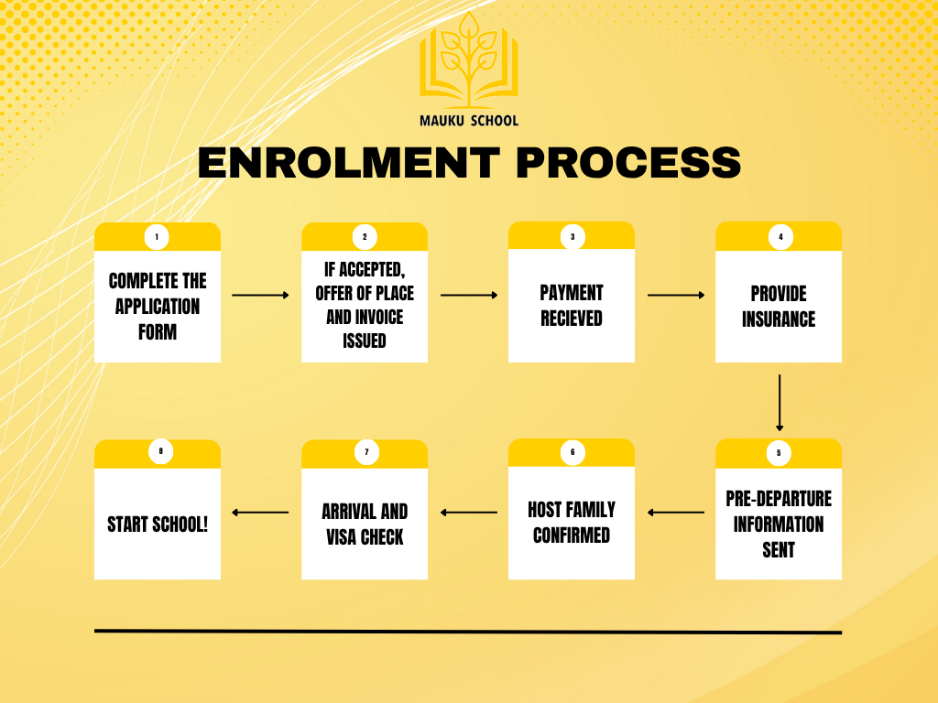

Visa

International students must hold a valid student visa for the duration of their study. The school will check visa details on arrival.

Website Address

https://www.mauku.school.nz/

Support and Complaints
If students or families have any concerns, we encourage you to contact the school directly so we can support you and work towards a solution.
If a concern is not resolved, independent support is available through Study Complaints (www.studycomplaints.org.nz) or the New Zealand Qualifications Authority (NZQA):
https://www2.nzqa.govt.nz/about-us/contact-us/complaint/

Contacts for more information

 |  | 
Shane Keown  Deputy Principal / International Student Director / 24/7 Contact  022 044 2322  shane@mauku.school.nz | Chantelle O’Callaghan  Executive Officer / Pastoral Care Coordinator  chantelle@mauku.school.nz | Janine Taylor  Office Manager / Enrolment Officer  janine@mauku.school.nz

The Person Responsible for International Students is the Deputy Principal / International Student Director, who is the main point of contact for all international student matters.

We are here to support you every step of the way and look forward to welcoming your family to Mauku School.

